# Development Process:

Each concept and technique of DirectX 11 was first developed in separate projects to test them individually. This enabled to understand each concept in clear detail and have a better understanding. Then, a new project was created to put together all the concepts and develop the game at whole. The code was clearly split into various classes and all the relevant details were then declared, initialised, and used appropriately. The newer concepts were also developed separately to ensure it doesn’t disturb the main project. Some of the new concepts were implemented but failed to work. Some of these are UI which had overwritten all other models and textures when rendered (see Screenshot 1) and a skybox texture which failed to load in a texture (see Screenshot 2).



Screenshot 1. The game screen with UI but everything else overwritten

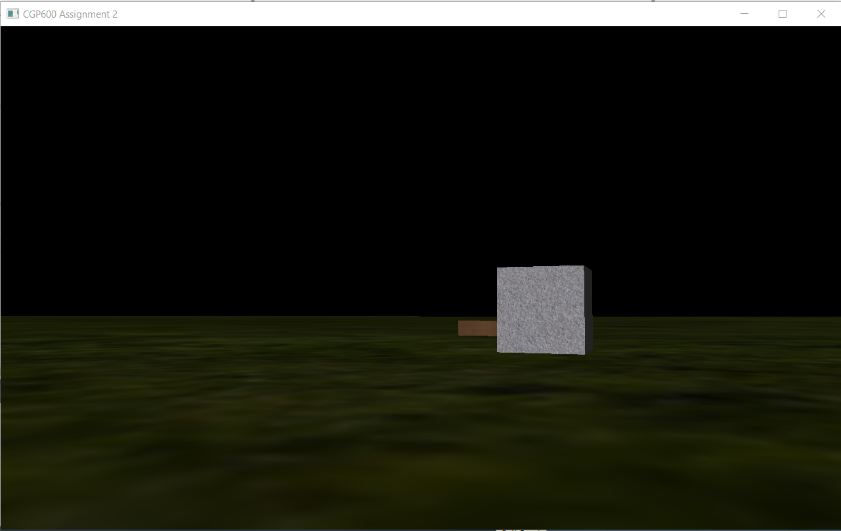

Screenshot 2. The black portion is the skybox but with no texture

# Implementation Changes:

The game was designed to be in third-person, but the game was implemented in first-person. The reason for this change is because the implementation process for third-person proved to be far more complex than the first-person camera. The axis needed to be relative to the player for the camera to rotate around the player and it required a lot of processes. So, the idea of third-person camera was discarded. Moreover, the game was better viewed and played in first-person and provided a lot of ease for the developer to test and play the game.

The game was also designed to have fruits which increases the player’s health. It could have been easily implemented but with the issue of not having UI in the game, the developer was unable to display the player’s health, so the relevant changes could not be displayed.